Dealing with anxiety
Having lived through an earthquake, Amir, a 9-year old boy, became withdrawn and experienced anxiety attacks that led him to pull out his hair, always from the same spot on his head. A Red Cross volunteer talked with Amir, and they agreed that he would count to one hundred whenever he became anxious. This made Amir concentrate on something other than his anxiety, and helped him resume his normal behaviour.
Children need to know
Children and adolescents need information about what has happened in an age appropriate manner. Caregivers should encourage children to ask questions, and use their questions as a guide when talking. 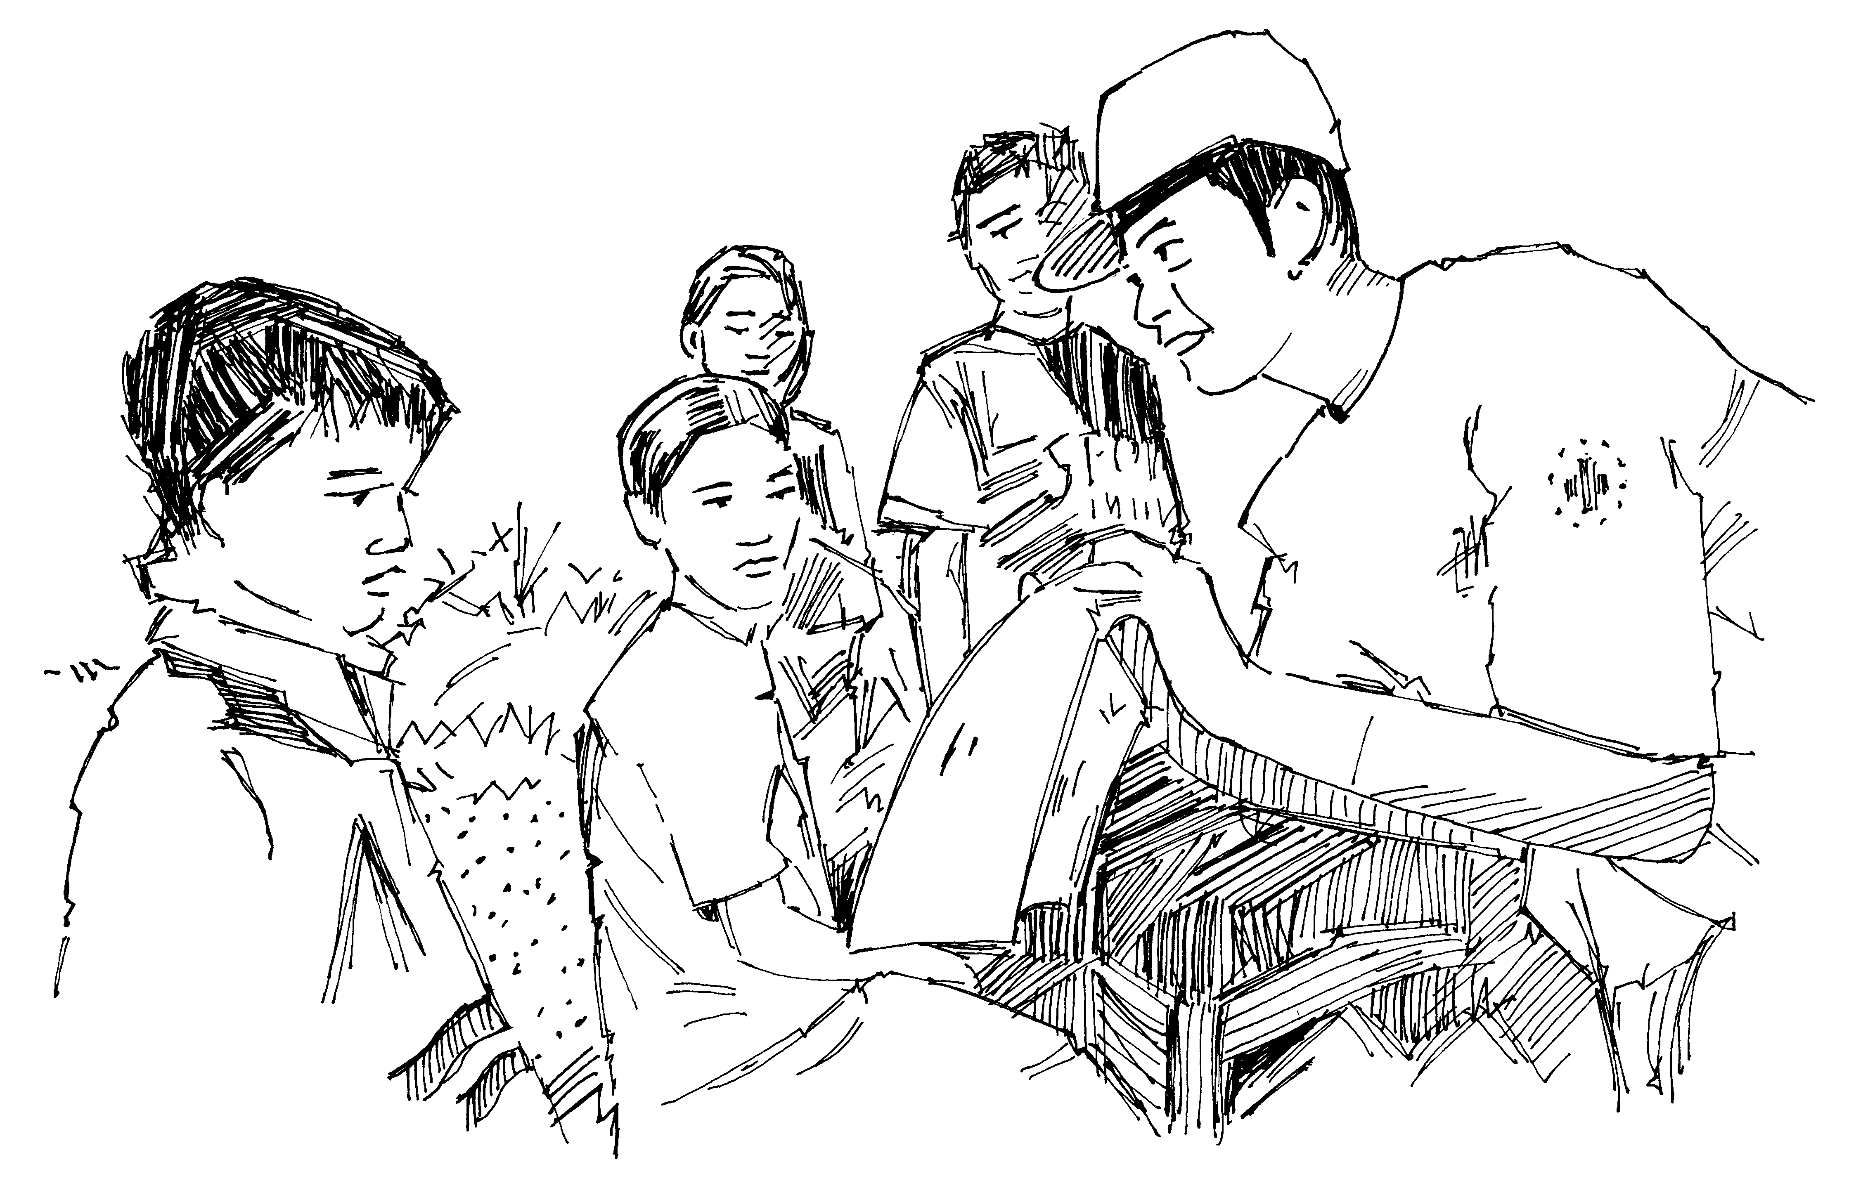
Talking is important, however children should not be overwhelmed with information that they did not ask for. It is important to be honest and to use words that children understand. Make it clear that what happened was not a result of their actions. Avoid letting children hear ‘adult-talk’ about frightful things and do not let them watch upsetting news stories on TV.

For more information, contact us:
International Federation Reference Centre for Psychosocial Support
Blegdamsvej 27, 2100 Copenhagen,
Denmark
+45 35 25 92 00
http://psp.drk.dk
psychosocial.center@ifrc.org

This brochure was made with the support of
Illustrations: Rod Shaw/International Federation

Children’s stress – their reactions and how to support them, for parents and caregivers

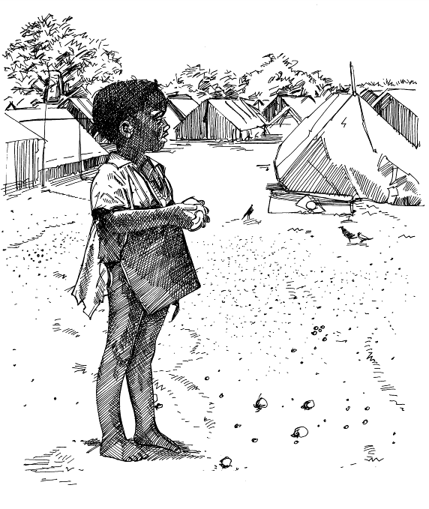

Children also react
If a child has gone through a crisis event or situation, he or she needs support. Like adults, children react to the stress.
This brochure explains children’s reactions to stress and crisis situations, and shows how caregivers, whether parents, relatives, teachers or others, may help the children.
Positive, negative and extreme stress
Stress is an ordinary feature of everyday life. It is positive when it makes a person perform well. But stress can put negative pressure upon any child or adult. If children are faced with a strong or sudden strain such as a crisis or a great loss, they may experience extreme stress. The same can happen if children are subject to ordinary negative stress over a longer period of time.
Children’s reactions to stress are different from those of adults, and so is their ways of grieving. Sometimes this difference is interpreted by adults as if children quickly forget and adapt. This is not the case even though some children may not show their feelings, nor express their grief in words. Children’s grieving periods are short; however a crisis event can have longer-lasting effects on children than on adults. Children are vulnerable to crisis and stress, and need care and support from adults around them.
Children’s reactions
After a stressful experience involving loss, children’s grief is often abrupt and they may switch quickly from intense grief reactions to play and having fun. Almost all children play, even if they have gone through an intense crisis event.
Younger children may behave aggressively towards caregivers or other children, while at the same time cling to their caregivers and show signs of separation anxiety. There may be changes in behaviour, e.g. regression to the behaviour of younger children such as bedwetting, thumb sucking, or not being able to sleep alone. This shows loss of trust. In such situations, stable and secure relationships are very important resources.
A child’s grief
Pedro, an eight-year-old boy who lost his mother in a car accident, attends her funeral. He is standing beside the grave crying intensely, when suddenly a cat appears. Immediately he stops crying and begins to play with the cat while the funeral goes on. After everybody has gone, Pedro sits down at the grave and reads a bedtime story to his mother and refuses to leave until his uncle suggests that they can go and get a big candle to put on the grave.
Older children may display stress symptoms such as avoiding friends and adults and appearing moody. Some establish a sense of control by becoming perfectionists, while others display a decline in performance at school and otherwise. Adolescents may behave similar to adults, for example by isolating themselves or becoming irritable or aggressive.
It is important to remember that children’s stress reactions are normal reactions to an abnormal situation. Explain this to children when they do not understand their own reactions or find it hard to deal with them.
Supporting children
In a crisis situation, caregivers sometimes change their way of providing care. Children are best supported by keeping up daily routines, going to school if possible, or participating in other regular activities. Restore a certain kind of routine as soon as possible, such as maintaining eating and sleeping routines. Celebrate birthdays and special occasions if possible. 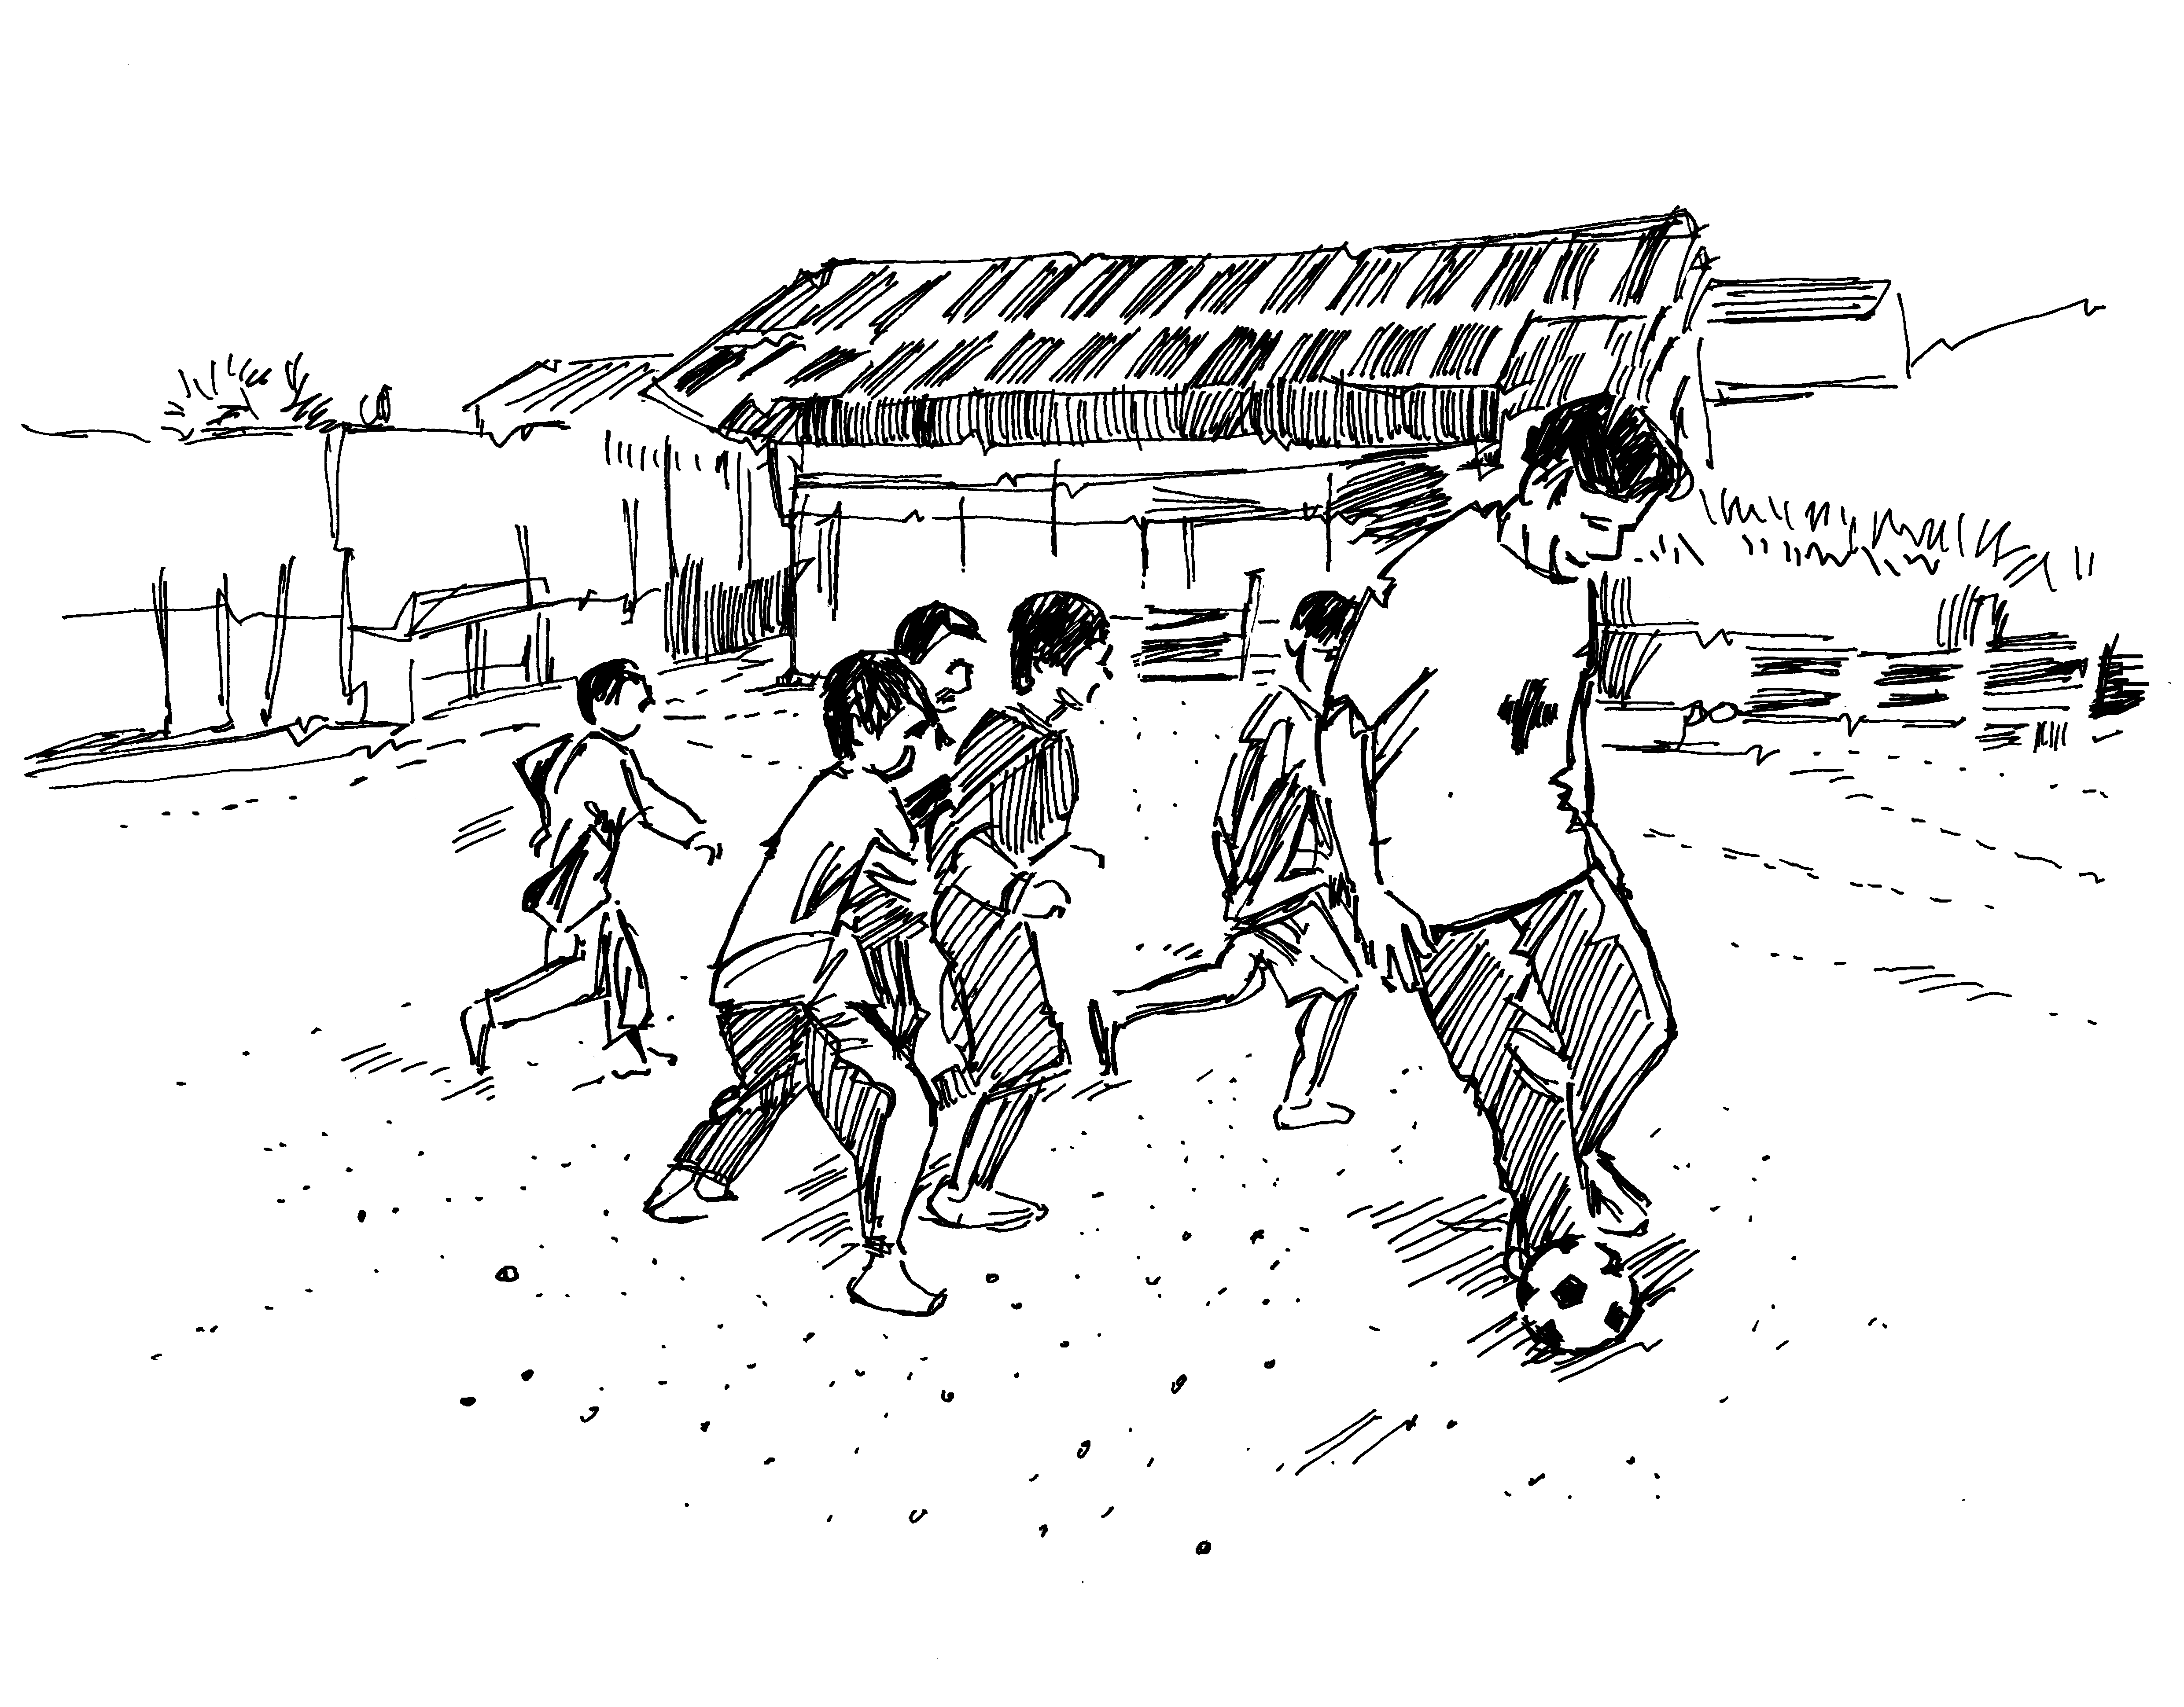
Children need as much normality, play and fun as possible and to be given a chance to regain their feelings of trust and safety. It is important that caregivers fulfill their roles as before, and don’t let the children take on adult roles.

